/\*\*\*\*\*\*\*\*\*\*\*\*\*\*\*\*\*\*\*\*\*\*\*\*\*\*\*\*\*\*\*\*\*\*\*\*\*\*\*\*\*\*\*

\* Programming excercise 73014 \*

\* Maxwell Stephens \*

\* 12:30 TTh \*

\* 4/27/17 \*

\*\*\*\*\*\*\*\*\*\*\*\*\*\*\*\*\*\*\*\*\*\*\*\*\*\*\*\*\*\*\*\*\*\*\*\*\*\*\*\*\*\*\*/

/\*

Simple addition calculator using arrays

\*/

#include <iomanip>

#include <fstream>

#include <iostream>

using namespace std;

int main() {

//declare vars

char num1[20];

char num2[20];

int int1;

int int2;

int intArray[20];

//get first number

cout << "Enter the first number" << endl;

cin >> num1;

//get second number

cout << "Enter the second number" << endl;

cin >> num2;

//convert to int using atoi

int1 = atoi(num1);

//convert to int using atoi again

int2 = atoi(num2);

//store sum in array

intArray[1] = int1 + int2;

//print sum

cout << "Sum of the numbers = " << intArray[1] << endl;

system("pause");

return 0;

}

/\*

SAMPLE OUTPUT:

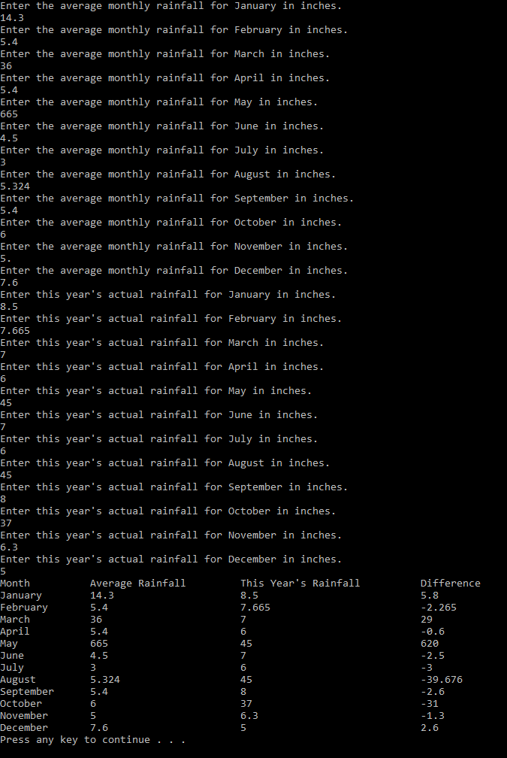

Self-Evaluation:

4: Works perfectly, code properly documented

I believe I earned 4 points.

\*/